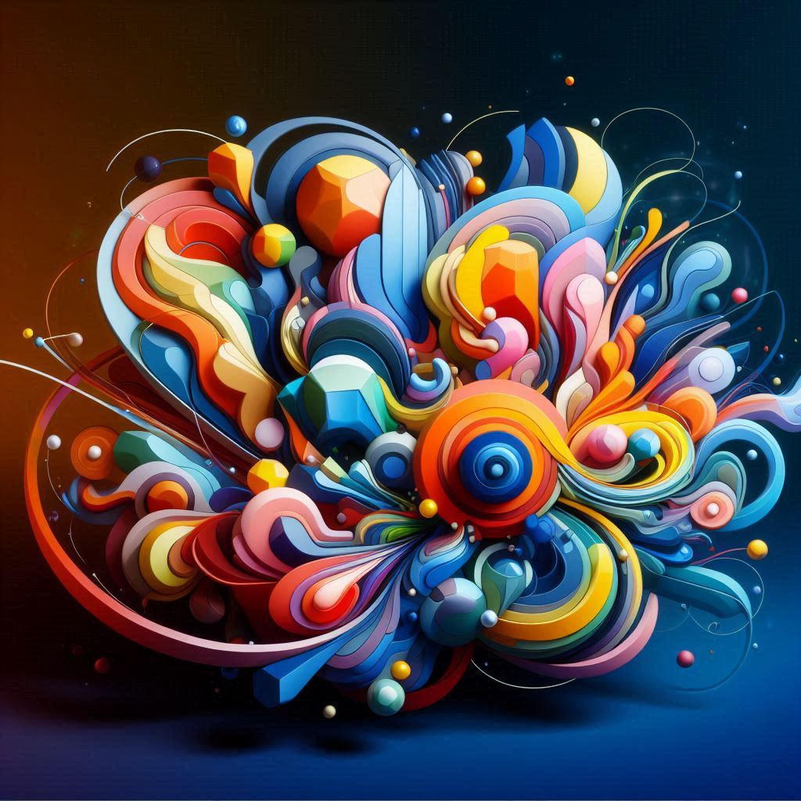The Polymodality Project
September 19, 2025

Audience
Are you a software engineer, developer, architect, modeler, or artisan? Ok, you make software with the power of your imagination. But what structure do you use to represent your thoughts? Maybe you use object modeling or many information modeling systems? Domain Modeling, Domain Driven Design, etc.? What is a “domain”? What is a subject area? Are these the same thing? Why does it even matter, I just let the AI spit out all the stuff I need anyway? Even AI has the same cognitive issues that we do. We often confuse ourselves with using the same word but it means totally different things in different contexts. This project aims to provide a solution to this problem. Often we build things that are not just from one domain, so then what happens?

The Mission
The world is made of “stuff” (described by models) that live in different contexts (situations or dimensions). Ok, what does that mean? The goal of this project is to create a system and tool that enables first class entity software development. This means to allow for a “thing” to be tied to its domain, and yet linked to the other contexts that it also lives in. The goal is to enable programming that is one programming construct equals one real-world / model concept. That sounds normal, we already have this no? No, we do not. All existing systems break down with any real world level of complexity. OOP has a great structure of representing the world, but it is always fake because the boundaries of the “world” are chosen to fit the project timelines, etc. Also, a software system always wants to use things in different ways that break the rules. There is no way to declare behavior in a software system that is based on situation in a programming language manner. it is always just a bunch of more code. Why is it that we do not utilize standard shared domain models? We can answer this question with many reasons, project priorities, requirements, context, many other reasons. The reason is because we don’t have a way to use an object / entity from one domain in a different situation, so we just create a new entity and copy over the data. Polymodality will solve this problem.

The Tool
Polymodality (pm) is a command line tool that does the things to models we seek. Compose a model based equation into a new model. This means a function or “English modification” will take one model and produce a new model. The tool will allow for scripts and any other language that is not directly supported by the library. What do you mean compose a model function into a new model result? The idea is to start with a standard model of a domain object and have the function add the missing parts to it that are needed due to the context of your system you are creating. This is what you would do manually, but in code in the form of an incantation. But it isn’t over with that. The system will let you interact with the class that makes sense for the situation at hand, and then when a new context comes into play, they system will do the magic to switch classes.

The Possibilities
The Polymodality Project opens up a world of possibilities for software development. By providing a structured system and tool for modeling real-world concepts, it allows developers to create more accurate and reliable software. With Polymodality, developers can:
Enhance Cognitive Clarity: By using a formal system to manage and structure thoughts, developers can reduce cognitive load and improve the clarity of their ideas. This leads to more efficient and effective software development.
Improve Consistency: Polymodality ensures that one programming construct equals one real-world/model concept. This consistency helps in maintaining the integrity of the software and reduces the chances of errors.
Adapt to Context: The tool allows for interaction with classes based on the situation and switches classes when a new context arises. This adaptability makes the software more flexible and responsive to changing requirements.
Streamline Development: By automating the process of composing model-based equations into new models, Polymodality saves developers time and effort. This streamlining of the development process leads to faster and more efficient software creation.
Foster Collaboration: With a common system and language for modeling concepts, Polymodality facilitates better communication and collaboration among team members. This leads to more cohesive and integrated software development efforts.
Standard Domain Models: With a library of real domain models that are created by domain experts so they are natural to the domain they are to represent, we can compose different models into what our application needs.

